**Machine Learning – Lecture Notes – Part III**

**Week 8**

**Unsupervised Learning**

**Introduction**

* In a supervised learning problem, we are given a set of labels and we must fit a hypothesis to it.
* In an unsupervised learning problem, our training data has no labels. We simply ask unsupervised learning algorithms to find some structure in the data for us.
* We can use a clustering algorithm to find clusters in data as follows.

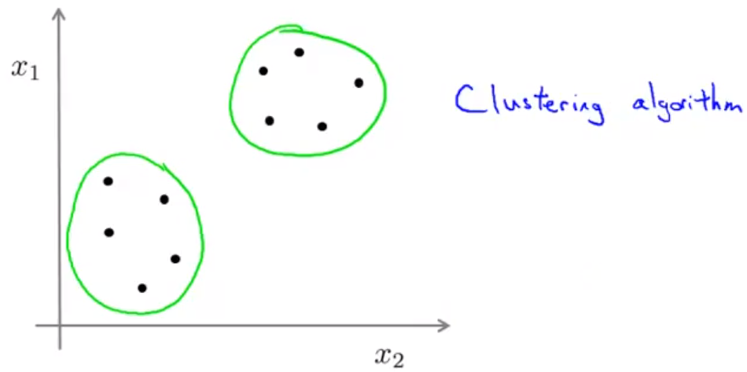

* Some applications of clustering include market segmentation, social network analysis, organizing computing clusters, astronomical data analysis, etc.

**K–Means Algorithm**

* Given an unlabelled data set, we first create $K$**cluster centroids** randomly in the data set, where $K$ is the number of clusters we want to group the data into. Then, there are 2 main steps in the algorithm.

1. First, we colour each of the data points based on which of the $K$ centroids it’s closest to.
2. Then, we move each of the $k$ centroids to the average of its coloured data points and we repeat the process.

* We iterate through these steps until the $K$ cluster centroids are at the centroids of their clusters.

K–Means Formalized

* Input
  + $K$ (number of clusters)
  + Training set $\left\{x^{\left(1\right)},x^{\left(2\right)},…,x^{\left(m\right)}\right\}$, and we say $x^{\left(i\right)}∈R^{n}$ (drop the $x_{0}=1$ convention)
* Randomly initialize $K$ cluster centroids $μ_{1},μ_{2},…,μ_{k}∈R^{n}$.
* Repeat {
  + for $i=1 to m$
    - $c^{\left(i\right)}≔$ index (from 1 to $K$) of cluster centroid closest to $x^{\left(i\right)}$ using $\min_{k∈\left\{1,…,K\right\}}{{\left\|x^{\left(i\right)}-μ_{k}\right\|}^{2}}$.
  + for $k=1$ to $K$
    - $μ_{k}≔$ average (mean) of points assigned to cluster $k$
  + }
* If a certain cluster has no points closer to it, then you can either (a) eliminate that cluster so there are $K-1$ clusters or (b) reinitialize that cluster centroid at a new location.

K–Means for Non–Separated Clusters

* Even when it looks like there are no clusters in the data, we can make clusters out of it.
* For example, given people’s heights and weights, we can segment the market for T-shirts into 3 different classes of data – small, medium and large, and design T-shirts based on those market segmentations.

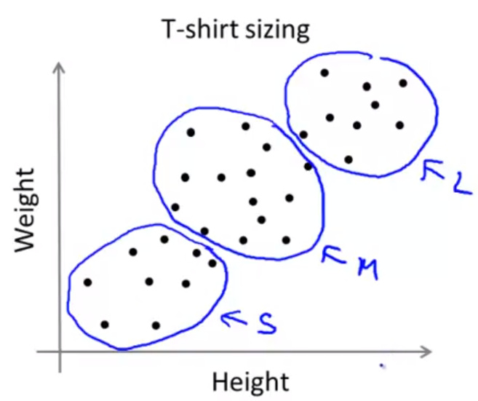

**Optimization Objective**

K-Means Optimization Objective

* Notation:
  + $c^{\left(i\right)}=$ index of cluster ($1, 2,…, K$) to which example $x^{\left(i\right)}$ is currently assigned
  + $μ_{k}=$ cluster centroid $k$, where $μ_{k}∈R^{n}$
  + $μ_{c^{\left(i\right)}}=$ cluster centroid of cluster to which example $x^{\left(i\right)}$ has been assigned
* Optimization objective:
$$J\left(c^{\left(1\right)},…,c^{\left(m\right)},μ_{1},…,μ_{K}\right)=\frac{1}{m}\sum_{i=1}^{m}{{\left\|x^{\left(i\right)}-μ_{c^{\left(i\right)}}\right\|}^{2}}$$

$$\min_{\begin{aligned}c^{\left(1\right)},…,c^{\left(m\right)} \\ μ_{1},…,μ_{K}\end{aligned}}{J\left(c^{\left(1\right)},…,c^{\left(m\right)},μ_{1},…,μ_{K}\right)}$$

* The K-means algorithm first minimizes with respect to $c$ and then with respect to $μ$.

**Random Initialization**

* Should have $K<m$.
* Randomly pick $K$ training examples $x^{τ\left(1\right)},x^{τ\left(2\right)},…,x^{τ\left(K\right)}$, where $τ\left(k\right)$ is the random $k^{th}$ training example.
* Set $μ_{1}=x^{τ\left(1\right)},μ_{2}=x^{τ\left(2\right)},…,μ_{K}=x^{τ\left(K\right)}$ for these $K$ examples.

Local Optima

* However, it is very possible that K-means gets stuck at a bad local optima that prevents it from reaching the global optimum.

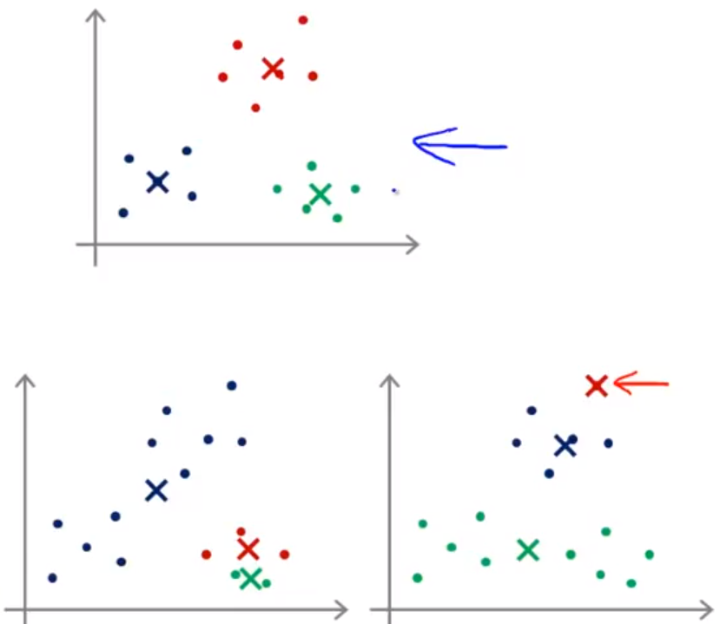

* To prevent this issue or get higher chances of remedying it, we can run random initialization many times and compare the cost function $J$ at each iteration and keep the best one.
* for $i=1$ to $100$ {
  + randomly initialize K-means
  + run K-means and get $c^{(1)},…,c^{\left(m\right)},μ_{1},…,μ_{K}$
  + compute cost function
 $$J\left(c^{\left(1\right)},…,c^{\left(m\right)},μ_{1},…,μ_{K}\right)$$

 + compare to the previous cost function and keep the parameters that yield lowest cost
  + }

**Choosing the Number of Clusters**

Elbow Method

* We run the K-means algorithm with varying number of clusters and plot the minimum cost $J$.
* Ideally, there is an “elbow” at which point, from the left, the cost function is decreasing rapidly, and from the right the cost function is decreasing slowly.

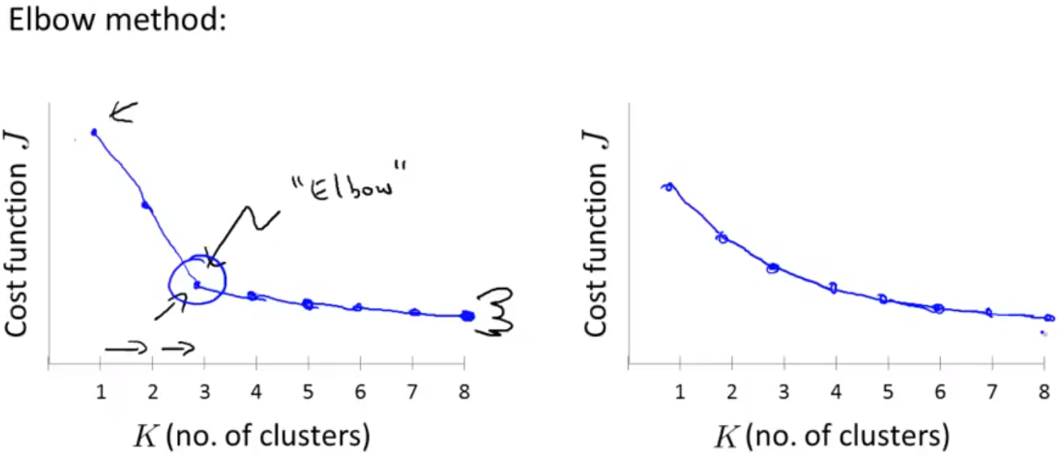

* However, we often end up with a curve on the right, where the elbow of the curve is ambiguous.

Choosing the Value of K

* We can train a current dataset based on how many clusters we will look for eventually. For example, in the market segmentation for T-shirts, we group the heights and weights of individuals into 3 categories to make a S, M, and L size for people.
* If I want more categories, namely XS, S, M, L, XL, then I pick $K = 5$.

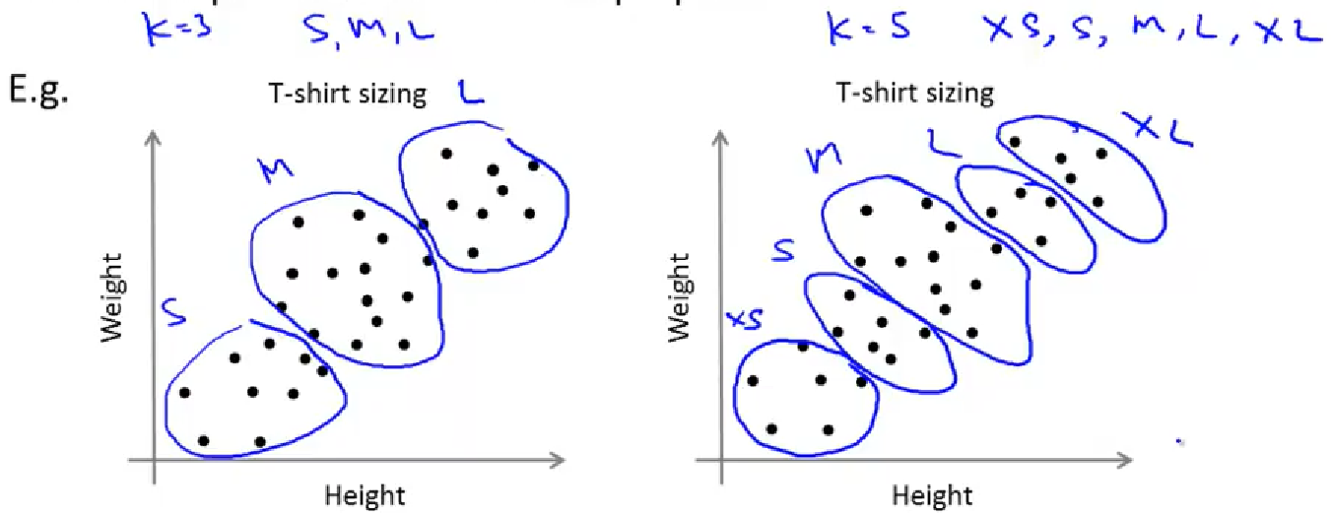

**Motivation I: Data Compression**

Dimensionality Reduction

* Reducing data from a higher dimension to a lower dimension (e.g. 2D 🡪 1D).
* If most data points sit on a straight line, then we can approximate both features by just using the *x-*value of the data points.

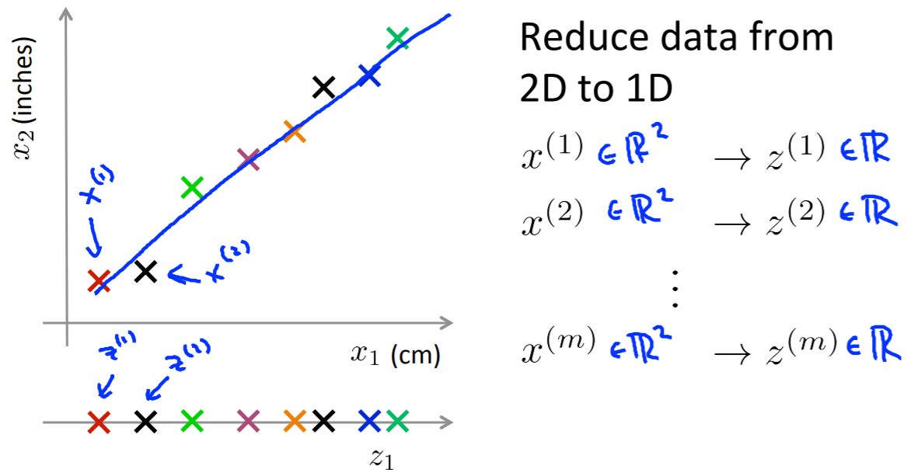

* Similarly, we can map 3D 🡪 2D if all/most of the data points lie on a single plane. We can make two axes $z_{1},z_{2}$ to represent the distance along each of the axes of the plane.

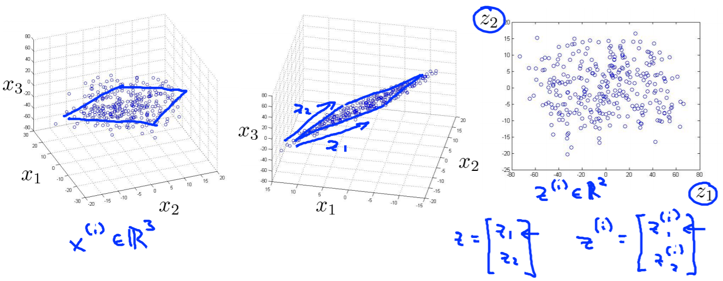

* Reducing the dimension data both saves storage space because less numbers are needed for the same data and makes learning algorithms more efficient since they require less computation.

Motivation II: Data Visualization

* When given data of high dimensions, such as 50-dimensional data, it is hard to visualize it.
* Using dimensionality reduction will help group certain features together to get lower dimensional data (i.e. 2D or 3D data) that can be plotted. This gives a better understanding of the data.
* For example, given many statistics about different countries like GDP, GDP per capita, HDI, life expectancy, Gini coefficient, mean household income, etc., we can reduce these figures into 2 categories: country size & per-person GDP (economic activity), yielding a graph like below.

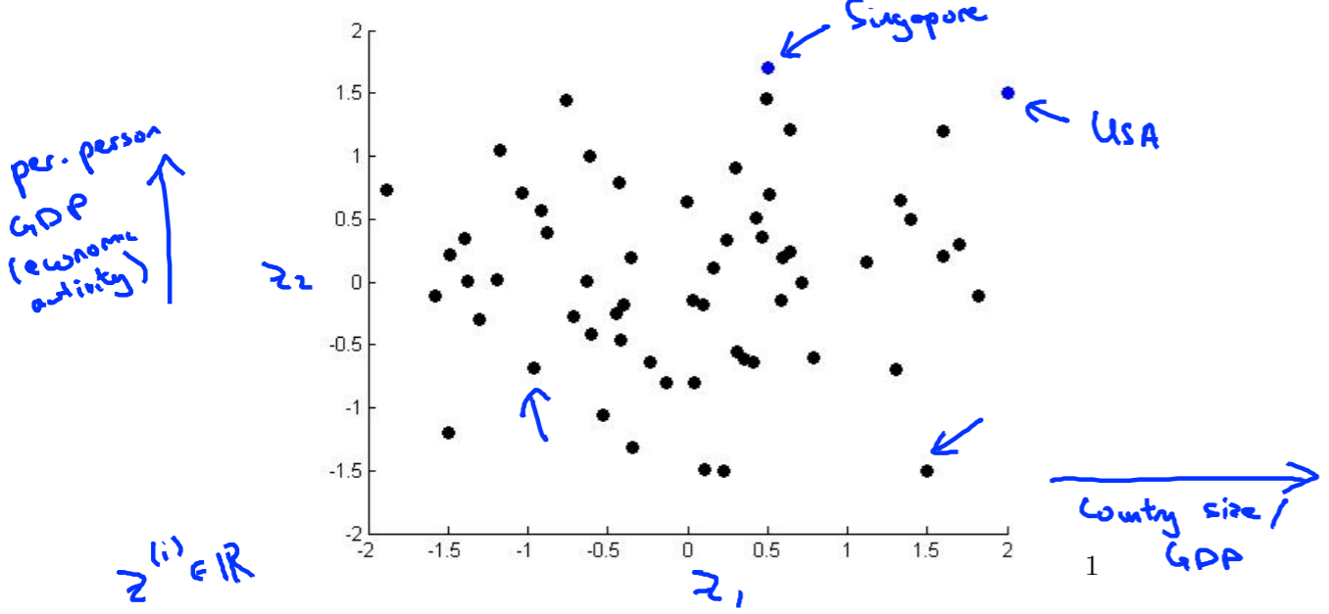

**Principal Component Analysis (PCA) Problem Formulation**

* The PCA problem is to reduce higher dimensional data into lower dimensional data.
* For example, with training examples $x^{\left(i\right)}∈R^{2}$, we can simplify this data into a line if there is a straight line that adheres to the data.

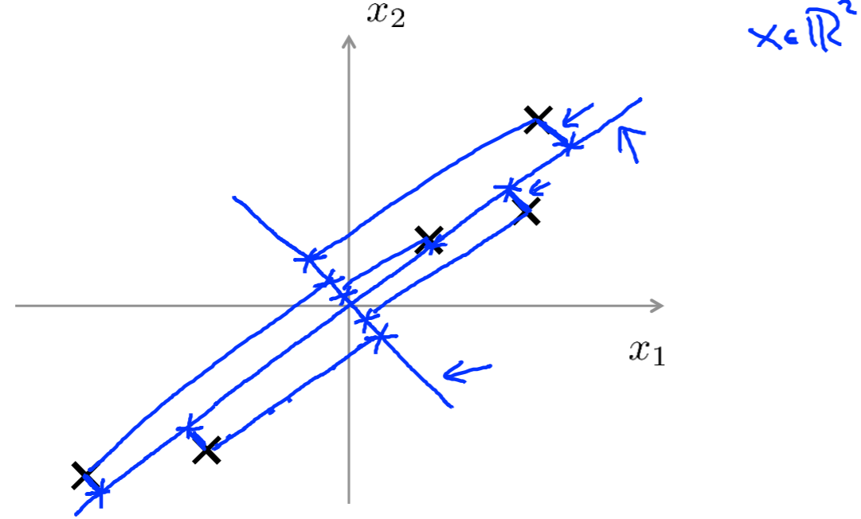

* Reduce from 2D 🡪 1D: Find a direction vector $u^{\left(1\right)}∈R^{2}$ onto which to project the data as to minimize projection error.
* Reduce from $n$-dimensional 🡪 -dimensional: Find $k$ vectors $u^{\left(1\right)},u^{\left(2\right)},…,u^{\left(k\right)}∈R^{n}$ onto which to project the data as to minimize projection error.

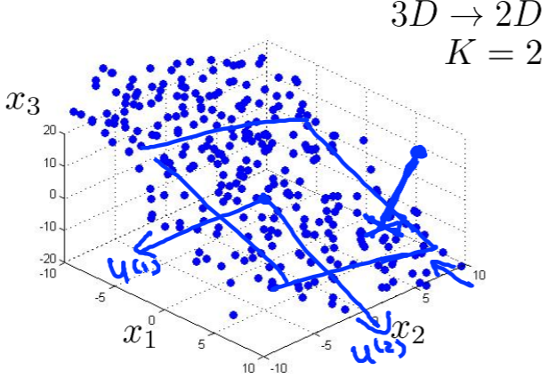

PCA is **not** Linear Regression

* Although PCA looks like linear regression, their goals are quite different.
* Linear regression tries to predict a variable $y$ based on an input $x$ and calculates the error as the sum of squares of the **vertical distance** from each point to the line.
* PCA tries to find a line to represent the relationship between variables $x_{1}$ and $x_{2}$ and calculates the error as the sum of squares of the **orthogonal distance** from each point to the line.

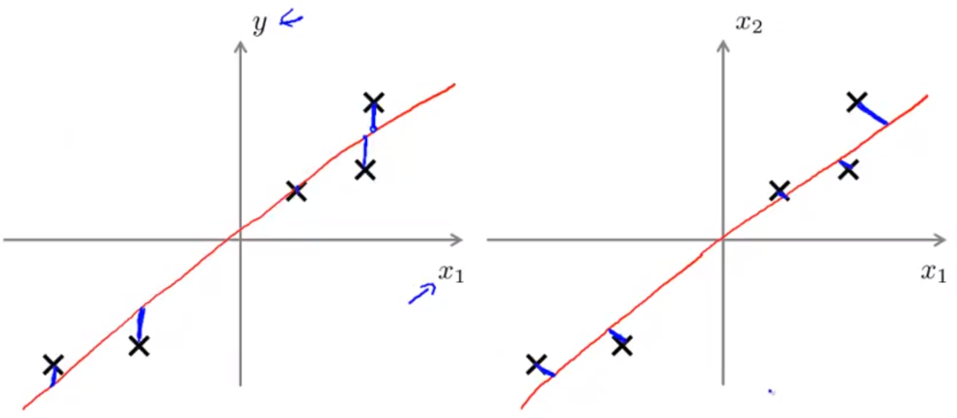

**Principal Component Analysis (PCA) Algorithm**

Data Preprocessing

* Given a training set $x^{\left(1\right)},x^{\left(2\right)},…,x^{\left(m\right)}$, we perform feature scaling & mean normalization:
 $$μ_{j}=\frac{1}{m}\sum_{i=1}^{m}{x_{j}^{\left(i\right)}}$$

 + Replace each $x_{j}^{\left(i\right)}$ with $x_{j}-μ_{j}$.
  + If different features are on different scales (e.g. $x_{1}=$ size of house (ft2), # of bedrooms), scale features to be on similar ranges (e.g. -1 to 1, or 0 to 1).

Principle Component Analysis (PCA) Algorithm

* Goal is to reduce data from $n$-dimensions to $k$-dimensions.
* Compute the “covariance matrix”:
$$Σ=\frac{1}{m}\sum_{i=1}^{n}{\left(x^{\left(i\right)}\right){\left(x^{\left(i\right)}\right)}^{T}}$$

* (The $Σ$ matrix will be $n×n$, since $\left(x^{\left(i\right)}\right)$ is $n×1$ and ${\left(x^{\left(i\right)}\right)}^{T}$ is $1×n$.)
* Now compute “eigenvectors” of matrix $Σ$ by using [U, S, V] = svd(Sigma);, where svd stands for singular value decomposition.
* Now we have the matrix $U$ and we can take the first $k$ columns to get our direction vectors upon which to map the data.

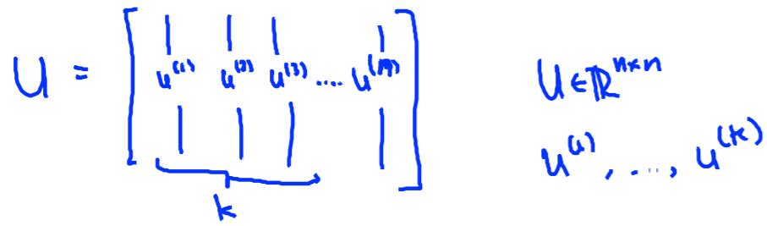

* Then, to compute the vector $z$ (our reduced input vector), we calculate this via $z=U_{reduce}^{T}x$, where $U_{reduce}$ is the first $k$ columns of the $U$ matrix.

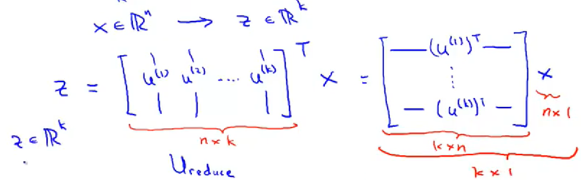

* The vectorized implementation is as follows.

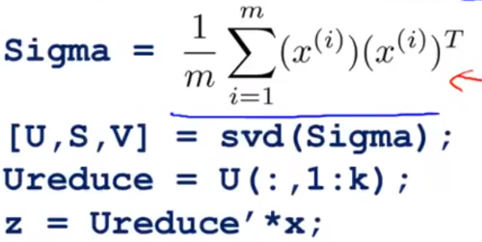

**Reconstruction from Compressed Representation**

* Once we have found $z$, there should be some way to go back to find $x$. Since we have $z=U_{reduce}^{T}x$, we can calculate an approximation $x≈x_{approx}=U_{reduce}z$.

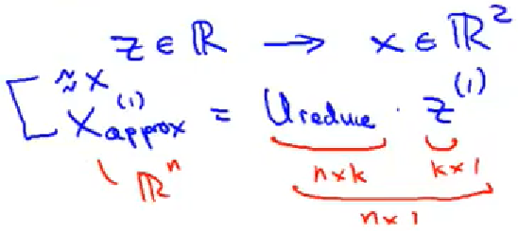

* What you find is that the approximate data fits the line perfectly because all the errors have disappeared. Thus, it is most effective to implement the PCA algorithm when the sum of squares of **orthogonal distances** is small.

**Choosing the Number of Principal Components**

* The PCA algorithm tries to minimize the average squared projection error.
$$\frac{1}{m}\sum_{i=1}^{m}{{\left\|x^{\left(i\right)}-x_{approx}^{\left(i\right)}\right\|}^{2}}$$

* We also have something called the total variation in the data.
$$\frac{1}{m}\sum_{i=1}^{m}{{\left\|x^{\left(i\right)}\right\|}^{2}}$$

* Typically, we choose $k$, the number of principal components, to be the smallest value so that:
$$\left(\frac{\frac{1}{m}\sum_{i=1}^{m}{{\left\|x^{\left(i\right)}-x_{approx}^{\left(i\right)}\right\|}^{2}}}{\frac{1}{m}\sum_{i=1}^{m}{{\left\|x^{\left(i\right)}\right\|}^{2}}}\right)=\frac{\sum_{i=1}^{m}{{\left\|x^{\left(i\right)}-x_{approx}^{\left(i\right)}\right\|}^{2}}}{\sum_{i=1}^{m}{{\left\|x^{\left(i\right)}\right\|}^{2}}}≤0.01$$

* The above means that “99% of the variance is retained”.

Efficient Algorithm

* There is a better way of computing $k$. After calling the SVD function on $Σ$, we get [U, S, V] = svd(Sigma), and the matrix S is a diagonal matrix so that only the elements on the diagonal are non-zero.
$$S=\left[\begin{matrix}s_{11} & 0 & 0 \\ 0 & ⋱ & 0 \\ 0 & 0 & s_{nn}\end{matrix}\right]$$

* Then, for given $k$, to assure that we have $99\%$ variance, we can test if
$$1-\frac{\sum_{i=1}^{k}{S_{ii}}}{\sum_{i=1}^{n}{S_{ii}}}≤0.01 \\ ⇔\frac{\sum_{i=1}^{k}{S_{ii}}}{\sum_{i=1}^{n}{S_{ii}}}≥0.99$$

* We can do this by creating a for loop and checking at each value of $k$ from 1 to $n$, if this value is $≥0.99$.

**Advice for Applying PCA**

* Given a training set $\left(x^{\left(1\right)},y^{\left(1\right)}\right),\left(x^{\left(2\right)},y^{\left(2\right)}\right),…,\left(x^{\left(m\right)},y^{\left(m\right)}\right)$, if each feature vector $x^{\left(i\right)}∈R^{10000}$, then it will be hard to run a supervised learning algorithm on it.
* Then, we apply PCA to get reduced feature vectors $z^{\left(i\right)}∈R^{1000}$ that retain 99% of variance, for example.
* Then, we have a new training set $\left(z^{\left(1\right)},y^{\left(1\right)}\right),\left(z^{\left(2\right)},y^{\left(2\right)}\right),…,\left(z^{\left(m\right)},y^{\left(m\right)}\right)$. Then, train our hypothesis using our prediction function $h_{θ}\left(z\right)$.

Applications of PCA

* Compression
  + Reduce memory/disk space needed to store data
  + Speed up learning algorithms
* Visualization (usually choose $k=2$ or $k=3$)
* An **incorrect use** of PCA is to prevent overfitting. Use $z^{\left(i\right)}$ instead of $x^{\left(i\right)}$ to reduce the number of features to $k<n$.
* The problem is that this algorithm doesn’t know the output labels $y$, and so it could be throwing away useful information. While you can guarantee that “99% of the variance will be retained”, regularization is usually better because the algorithm knows the training outputs $y$.

**Week 9**

**Anomaly Detection**

**Density Estimation – Motivation**

Anomaly Detection

* Let’s say aircraft engine features include $x_{1}=$ heat generated, $x_{2}=$ vibration intensity, etc. We have a dataset $\left\{x^{\left(1\right)},x^{\left(2\right)},…,x^{\left(m\right)}\right\}$.
* We can plot, for instance, $x_{1}$ versus $x_{2}$ on a graph to get a set of points.

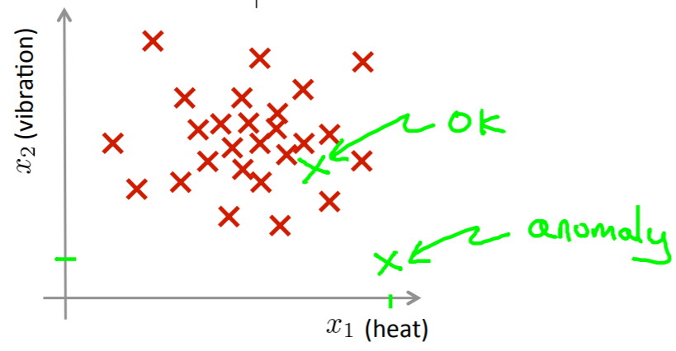

* Let’s say we have a new engine and the feature vector is $x_{test}$.

Density Estimation

* The approach we take is we build is a model $p\left(x\right)$ that estimates how likely a new aircraft engine is fully functioning.
  + If $p\left(x_{test}\right)<ε$, then we flag $x_{test}$ as an anomaly
  + If $p\left(x_{test}\right)≥ε$, then we say $x_{test}$ is a normal engine

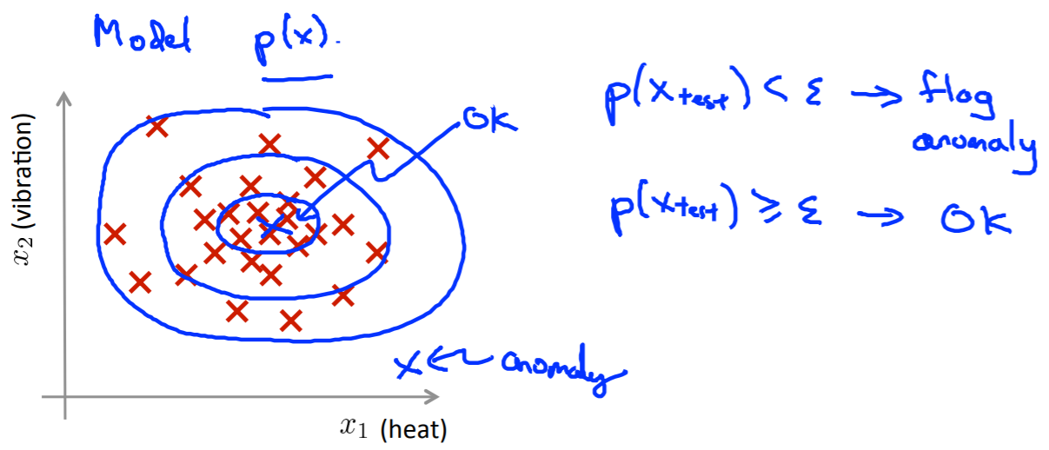

Anomaly Detection Example

* Fraud Detection
  + $x^{\left(i\right)}=$ features of user $i$’s activities
  + Model $p\left(x\right)$ from data
  + Identify unusual users by checking if $p\left(x\right)<ε$
* Manufacturing
  + Aircraft engine checking
* Monitoring computers in a data centre
  + $x^{\left(i\right)}=$ features of machine

* + memory use, $x_{2}=$ number of disk accesses/sec, $x_{3}=$ CPU load, $x_{4}=$ CPU load/network traffic
  + Model $p\left(x\right)$ from data
  + Identify unusual performing machines by checking if $p\left(x\right)<ε$

**Gaussian Distribution**

* Say $x∈R$. If $x$ is a distributed Gaussian with mean $μ$ and variance $σ^{2}$, then we can write $x \sim N\left(μ,σ^{2}\right)$ or “ $x$ is parameterized by $μ$ and $σ^{2}$”.
$$p\left(x; μ,σ^{2}\right)=\frac{1}{σ\sqrt{2π}}\exp\left(-\frac{{\left(x-μ\right)}^{2}}{2σ^{2}}\right)$$

* We get a probability distribution like the following.

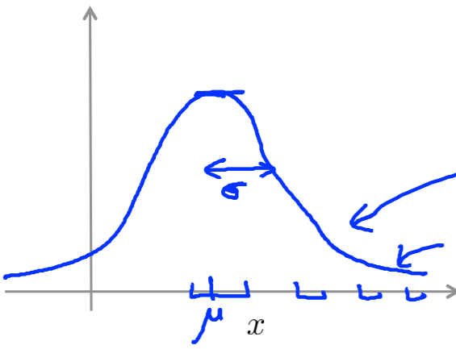

* The area under the curve of the Gaussian distribution is always 1 (a property of all probability distributions).

Parameter Estimation

* We can calculate the parameters of the Gaussian distribution given a dataset $\left\{x^{\left(1\right)},x^{\left(2\right)},…,x^{\left(m\right)}\right\}$, where $x^{\left(i\right)}∈R$.

$$μ=\frac{1}{m}\sum_{i=1}^{m}{x^{\left(i\right)}}$$

$$σ^{2}=\frac{1}{m-1}\sum_{i=1}^{m}{{\left(x^{\left(i\right)}-μ\right)}^{2}}$$

**Algorithm**

* For a density estimation problem, we can model $p\left(x\right)$ as the following.
$$p\left(x\right) \\ =p\left(x_{1};μ,σ_{1}^{2}\right)∙p\left(x_{2};μ,σ_{2}^{2}\right)∙∙∙p\left(x_{m};μ,σ_{m}^{2}\right) \\ =\prod_{i=1}^{m}{p\left(x_{i};μ_{i},σ_{i}^{2}\right)}$$

* Here is an outline of the entire anomaly detection algorithm.

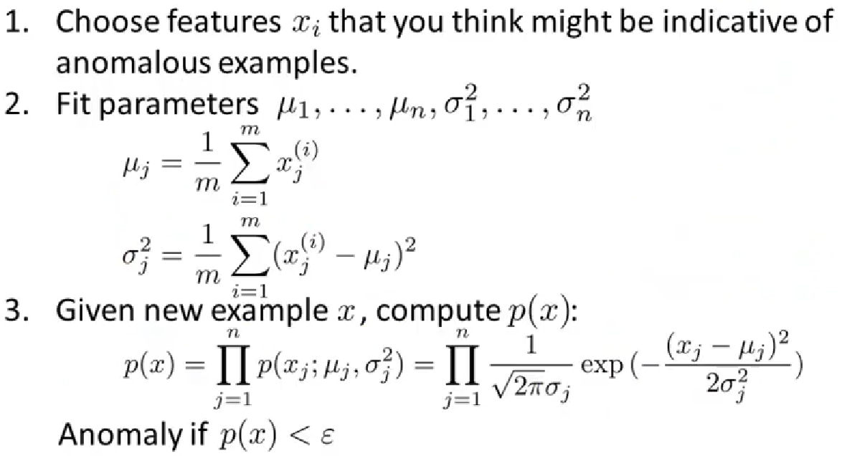

**Developing and Evaluating Anomaly Detection System**

* Making decisions about an anomaly detection system is much easier if there is a number associated with the performance of the algorithm.
* Assume we have labeled data (of anomalies, so $y=0→$ normal, $y=1→$ anomalous).
* We think of the training set as $x^{\left(1\right)},x^{\left(2\right)},…,x^{\left(m\right)}$ (assuming normal examples/not anomalous).
  + Cross validation set: $\left(x_{cv}^{\left(1\right)},y_{cv}^{\left(1\right)}\right),\left(x_{cv}^{\left(2\right)},y_{cv}^{\left(2\right)}\right),…,\left(x_{cv}^{\left(m_{cv}\right)},y_{cv}^{\left(m_{cv}\right)}\right)$
  + Test set: $\left(x_{test}^{\left(1\right)},y_{test}^{\left(1\right)}\right),\left(x_{test}^{\left(2\right)},y_{test}^{\left(2\right)}\right),…,\left(x_{test}^{\left(m_{test}\right)},y_{test}^{\left(m_{test}\right)}\right)$

Aircraft Engines Example

* Let’s say we have 10000 good normal aircraft engines and 20 flawed engines (anomalies) and their feature vectors. We could split our training set in the following way.
  + Training set: 6000 good engines ($y=0$)
  + CV: 2000 good engines ($y=0$), 10 anomalous ($y=1$)
  + Test: 2000 good engines ($y=0$), 10 anomalous ($y=1$)
* All the engines in each of the datasets will be distinct engines.
* We have the same prediction function as before.
$$y=\left\{\begin{aligned}1 if p\left(x\right)<ε \\ 0 if p\left(x\right)≥ε\end{aligned}\right.$$

* Possible evaluation metrics
  + True positive, false positive, false negative, true negative
  + Precision/recall
  + F1-score
* We can also use the cross-validation set to choose parameter $ε$ (for example, pick value of $ε$ that maximizes F1-score).

**Anomaly Detection versus Supervised Learning**

* We can display the differences between an anomaly detection algorithm and a supervised learning algorithm in a table.

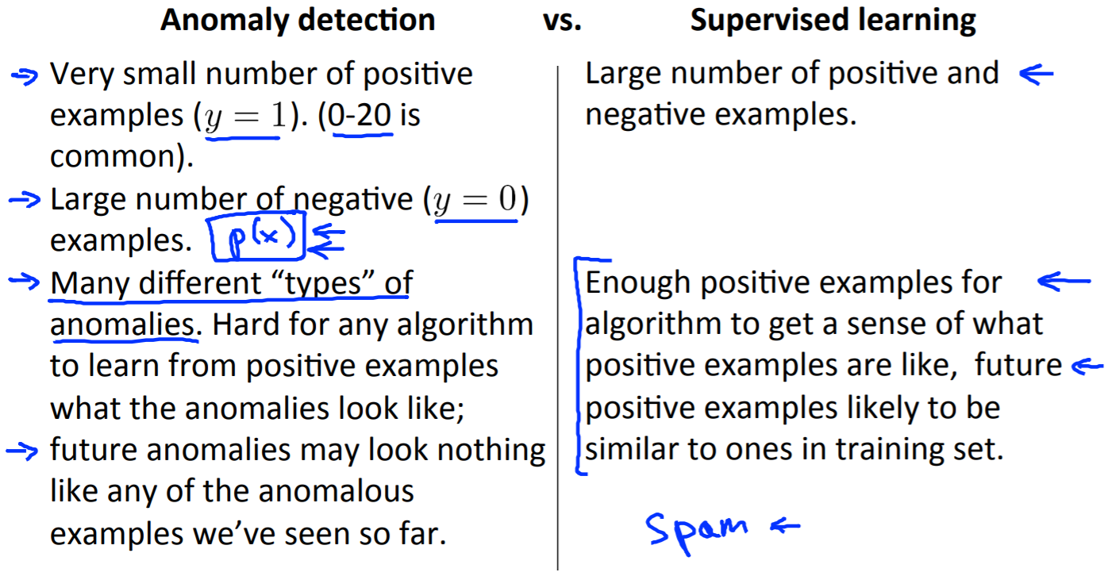

* The biggest difference between the two algorithms is that in anomaly detection, there is a very small number of positive examples (anomalies). Usually, a supervised learning algorithm wouldn’t be able to learn from the mistakes (especially when there are a range of mistakes that can be made for different reasons, like human error).

**Choosing What Features to Use**

* When we have features we would like to use for anomaly detection, we should make sure that these features fit a Gaussian curve.
* If they don’t fit a Gaussian distribution, then we can apply transformations so that it looks Gaussian.

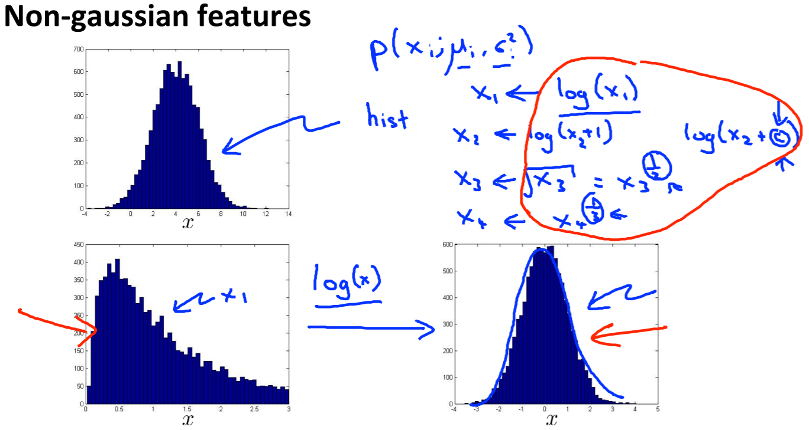

* We could apply the logarithm function or power function to center the data around a single point and make the distribution look bell shaped.

Error Analysis for Anomaly Detection

* We want $p\left(x\right)$ large for normal examples $x$

$p\left(x\right)$ small for anomalous examples $x$

* We train this anomaly detection algorithm and test it on a cross-validation set and look at the examples it got wrong.
* Then we see if we can come up with extra features that can correct the algorithm’s mistakes and then incorporate them into the algorithm.
  + *Most common problem: $p\left(x\right)$* is comparable (both large) for normal and anomalous examples

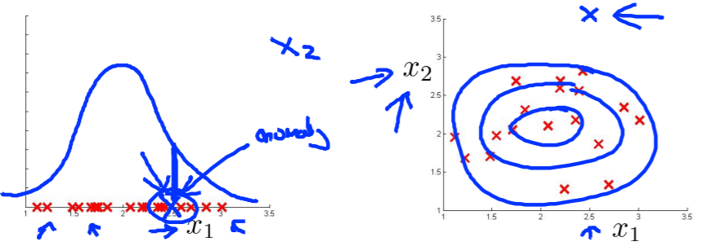

* For example, if feature $x_{1}$ has the distribution as above, and there is an anomaly, then it is still getting a high probability of being a normal example. However, if we can identify something missing with that example and add a new feature $x_{2}$, then it would appear as an outlier like it does in the graph on the right.

**Multivariate Gaussian Distribution (Optional)**

* Sometimes, we can’t model our features $x_{1},x_{2},…,x_{n}$ separately. In single variable Gaussian distributions, the assumption made is that each of the features is linearly independent, so the data just appears in clusters and there isn’t much of a relationship between them.
* However, for example, say we are monitoring machines in a data centre, using the features $x_{1}→$ CPU load, $x_{2}→$ memory usage.
  + These features are linearly dependent as shown below.

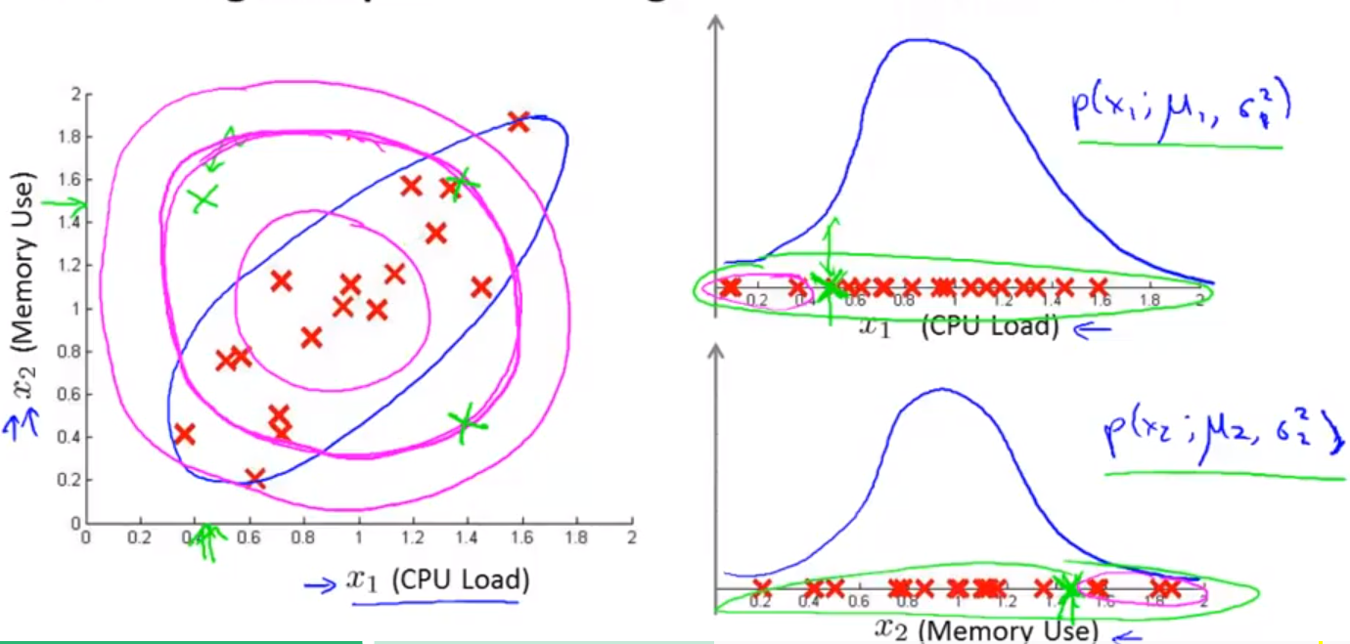

Multivariate Gaussian (Normal) Distribution

* $x∈R^{n}$. Parameters: $μ∈R^{n},Σ∈R^{n×n}$ (covariance matrix).
$$p\left(x;μ,Σ\right)=\frac{1}{{\left(2π\right)}^{n/2}{\left|Σ\right|}^{1/2}}\exp\left(-\frac{1}{2}{\left(x-μ\right)}^{T}Σ^{-1}\left(x-μ\right)\right)$$

* The function $\left|Σ\right|$ means the determinant of the $n×n$ matrix $Σ$.
* Without changing the covariance matrix, these distributions look like the following graphs, where the circles are of varying sizes.

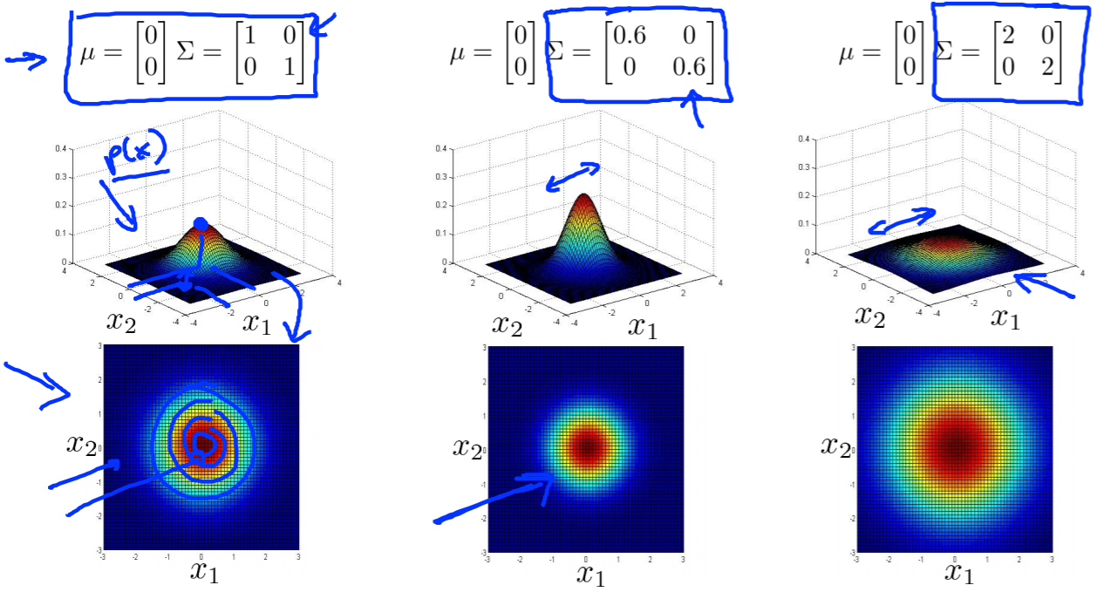

* By changing this covariance matrix, we can get a relationship to look like our dataset. Namely, $Σ$ is a diagonal matrix, so the off-entries are all 0s. By changing the 1s, we get the following graphs, which look more like ellipses.

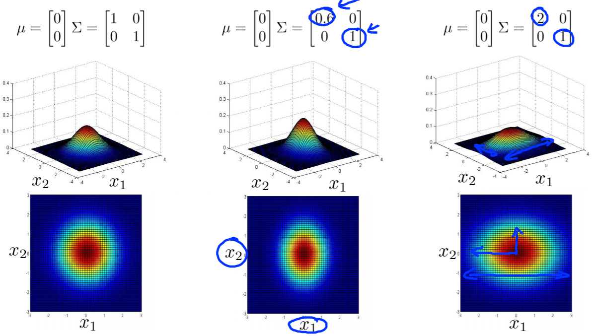

* When we change the off-diagonal entries of the covariance matrix, we can get a rotation in the ellipses to fit a custom distribution.

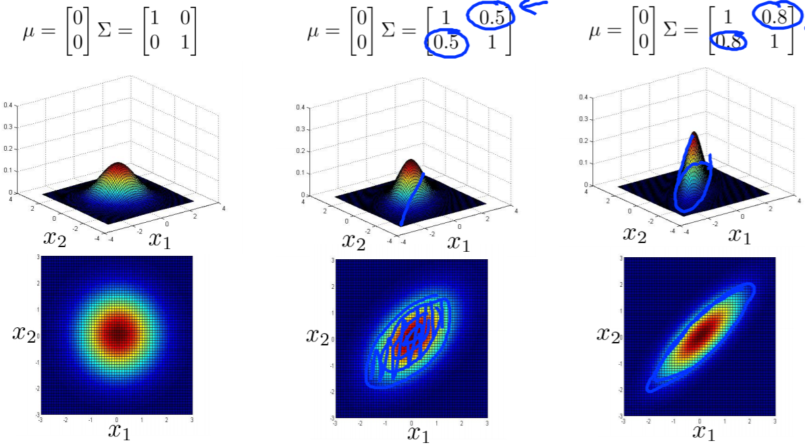

* We can vary the $μ$ to shift the circle/ellipse to a different location to fit our distribution as well.

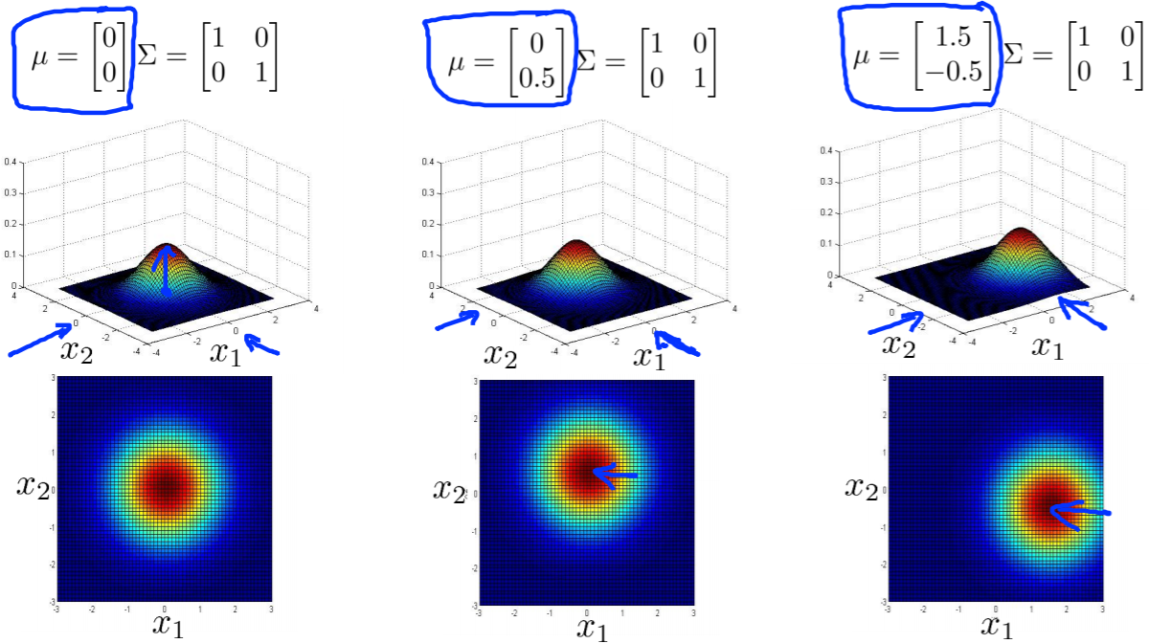

**Anomaly Detection using Multivariate Gaussian Distributions**

* We can fit the parameters $μ,Σ$ using the following formulas.
$$μ=\frac{1}{m}\sum_{i=1}^{m}{x^{\left(i\right)}}$$

$$Σ=\frac{1}{m}\sum_{i=1}^{m}{\left(x^{\left(i\right)}-μ\right){\left(x^{\left(i\right)}-μ\right)}^{T}}$$

* Below is the anomaly detection algorithm for the multivariate gaussian. As seen, it flags outer anomalies correctly.

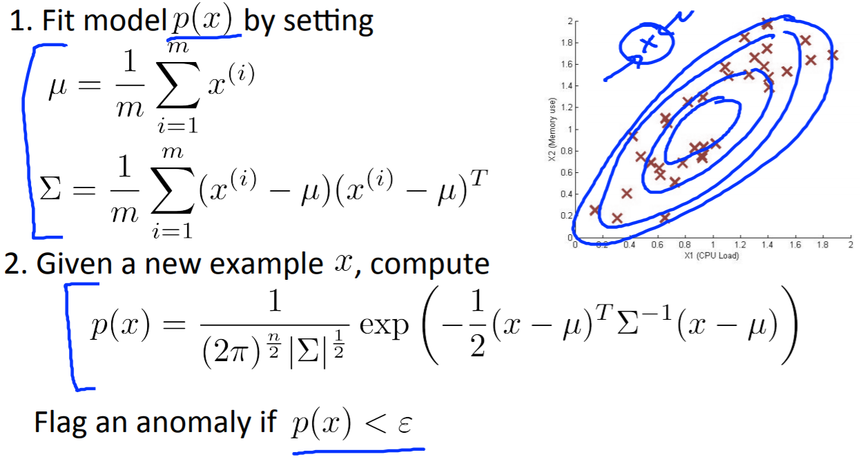

* Here are some of the different uses of the single and multivariate gaussian distributions and their benefits/drawbacks.

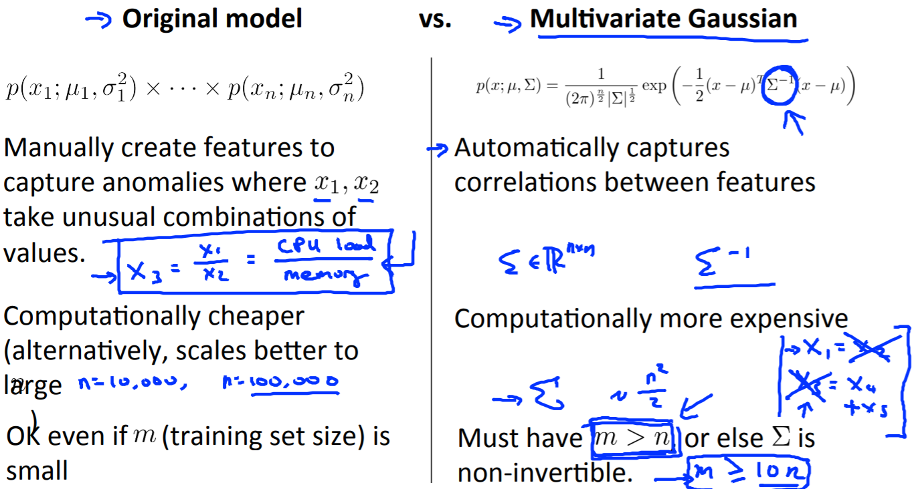

**Recommender Systems**

Example: Predicting Movie Ratings

* User rates movies using 0–5-star system. They don’t have to rate every movie, but let’s say we have the following rating matrix.

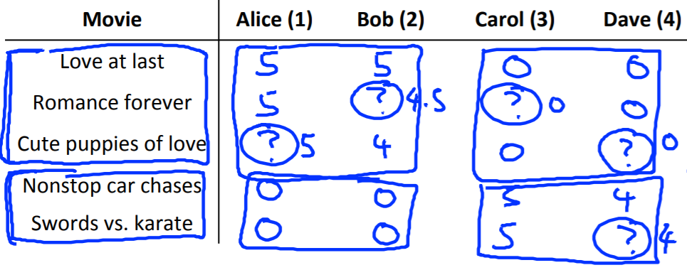

* The first set represents romance movies, while the second set represents action movies, so we can see that Alice and Bob like romance movies, while Carol and Dave prefer action movies from the given data.

**Content Based Recommendations**

* We can divide movies based on how much they are romance movies on a scale of 0 – 1 ($x_{1}$) and how much they are action movies on a scale of 0 – 1 ($x_{2}$).

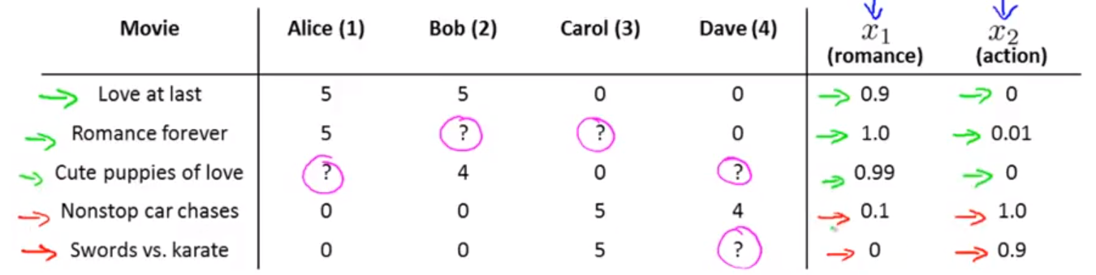

* Then for each user $j$, we learn a parameter $θ^{\left(j\right)}∈R^{3}$. Predict user $j$ as rating movie $i$ with ${\left(θ^{\left(j\right)}\right)}^{T}x^{\left(i\right)}$ stars.

**Collaborative Filtering**

* This is the full optimization objective of the collaborative filtering algorithm.

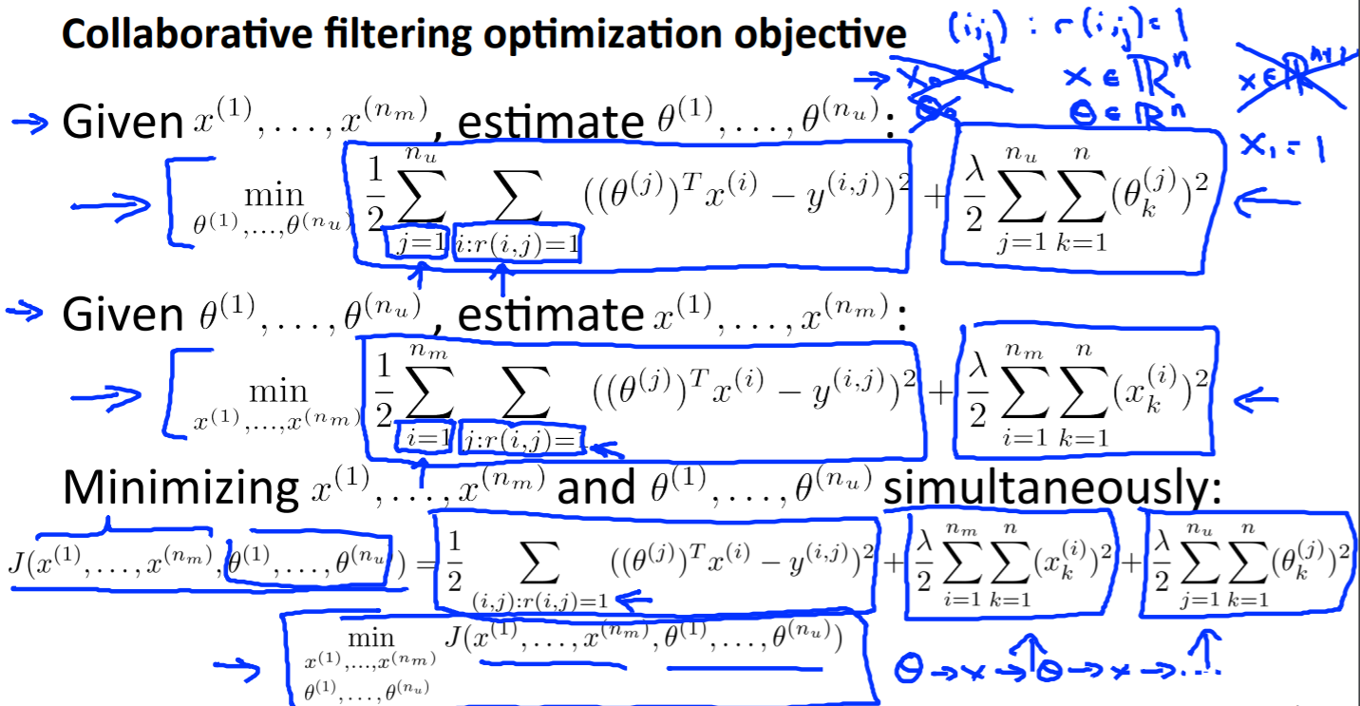

* Here are all the steps outlined.

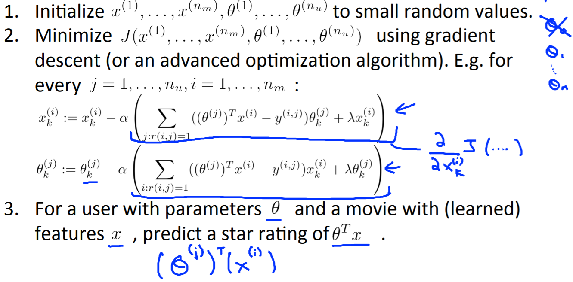

**Week 10**

**Large Scale Machine Learning**

**Stochastic Gradient Descent**

* Below are the outlined differences between **batch gradient descent** and **stochastic gradient descent**.

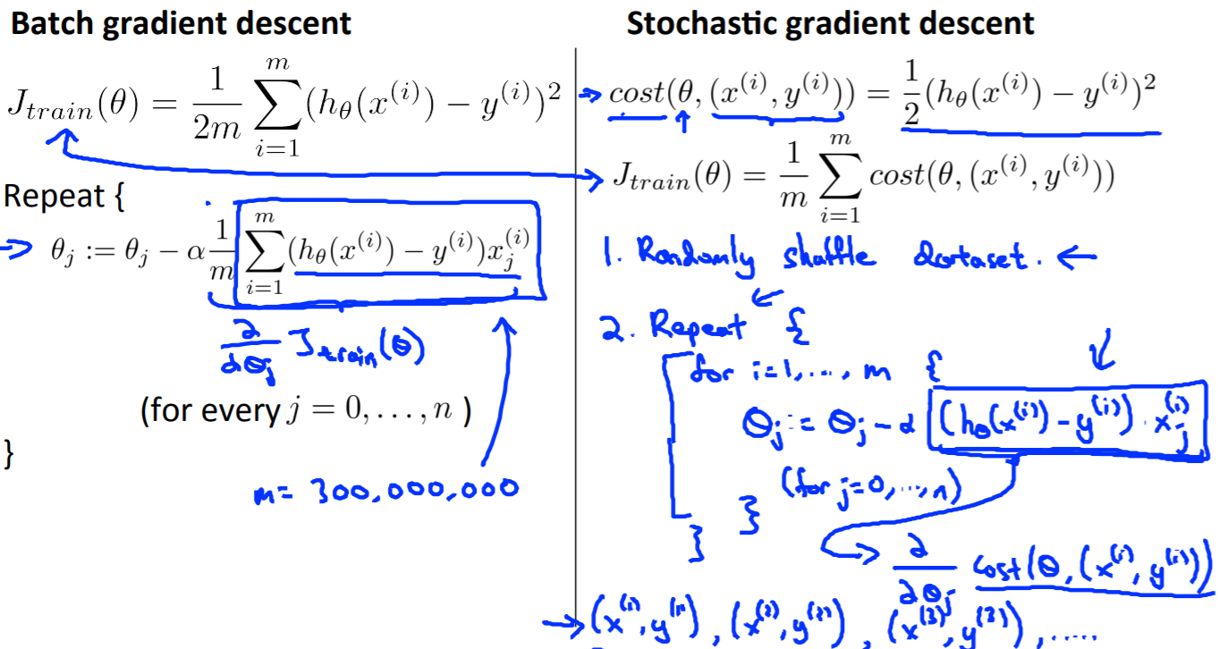

* Basically, on each iteration, the algorithm modifies the parameters a little bit after looking at only 1 training example.
* The dataset needs to be randomly shuffled to yield better chances of converging to the global optimum rather than a local optimum.
* The stochastic gradient descent algorithm takes a much more random path and converges close to the global minimum but doesn’t stay there.

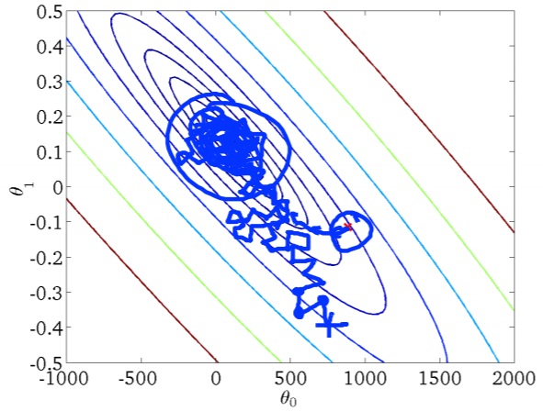

* However, this is not a problem since it gets close enough to the global optimum, so the cost is relatively low.

**Mini-Batch Gradient Descent**

* Here are different classes of gradient descent:
  + **Batch Gradient Descent:** Use all $m$ examples in each iteration
  + **Stochastic Gradient Descent:** Use $1$ example in each iteration
  + **Mini-Batch Gradient Descent:** Use $1<b<m$ examples in each iteration
* In each “step” of mini-batch gradient descent, we train on $b$ examples in every step until we get through all $m$ examples, so there are usually $\operatorname{ceil}\left(\frac{m}{b}\right)$ steps.

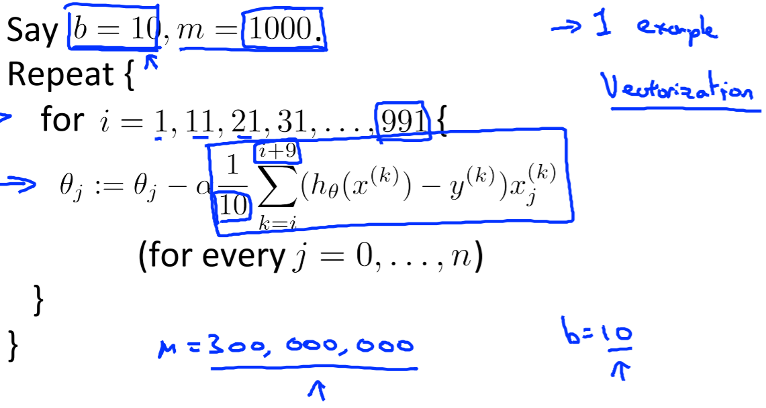

* We need a good **vectorized** implementation to outperform the **stochastic gradient descent** because it allows you to parallelize the computation.

**Stochastic Gradient Descent Convergence**

* In stochastic gradient descent, we compute the cost of the new training example before updating parameters $θ$.
* Then every 1000 iterations, for example, we plot $\operatorname{cost}\left(θ,\left(x^{\left(i\right)},y^{\left(i\right)}\right)\right)$ averaged over the last 1000 examples processed by the algorithm.
* We can see 4 different types of graphs that occur when using stochastic/mini-batch gradient descent and plotting the cost function over many iterations.

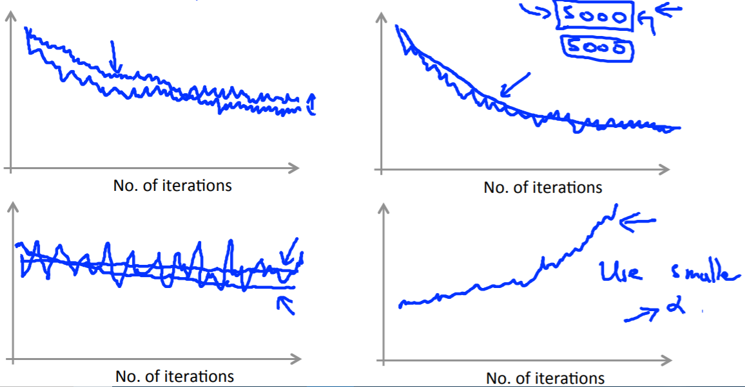

* + **Top-Left:** If the original cost function looks like the top-left curve, you could try using a *smaller learning rate* to decrease cost, but this is already a good solution.
  + **Top-Right:** If the original cost function looks like the top-right curve, you might average over each 1000 examples and get that plot. You could choose to average over *more examples* and get a smoother curve as shown.
  + **Bottom-Left:** If the original cost function looks constant, you could try *average over more examples* to get a smoother curve that shows the decreasing cost function. The first line might have been very noisy. (Cost could also not be decreasing, which could be a problem, so use a *smaller learning rate*.)
  + **Bottom-Right:** If your original cost function is increasing, you should *use a smaller learning rate* and check your learning algorithm isn’t wrong.

Learning Rate

* If you want your stochastic gradient descent to run faster and converge to the minimum, you could decrease your learning rate $α$ as you increase number of iterations. You could set $α=\frac{k_{1}}{i+k_{2}}$, where $i$ is the iteration number and $k_{1},k_{2}$ are constants.
* This way, the meanderings of gradient descent will become smaller as iterations increase, so it will look like the following curve.

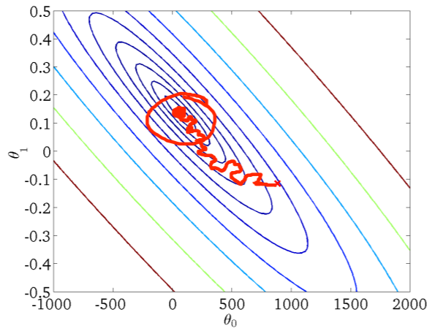

**Map, Reduce and Data Parallelism**

* The idea is that we can divide up the workload of a machine learning algorithms on different machines. They can compute different portions of the training set in parallel and then put them back together.

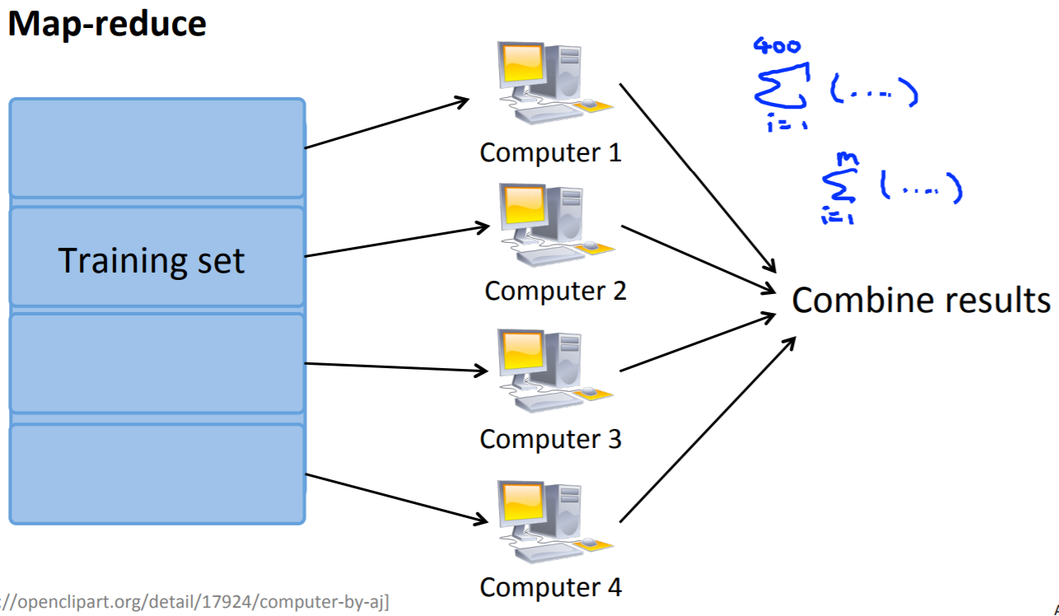

* Even in a single computer, you can parallelize tasks by splitting a training set between multiple cores to train the machine learning algorithm faster.